**Jump server:**

* There is one more concept called jump/bastion host. We do create this in public subnet
* The users will have their account in this jump box. So, they connect to this box and through that they can connect to APP/DB server

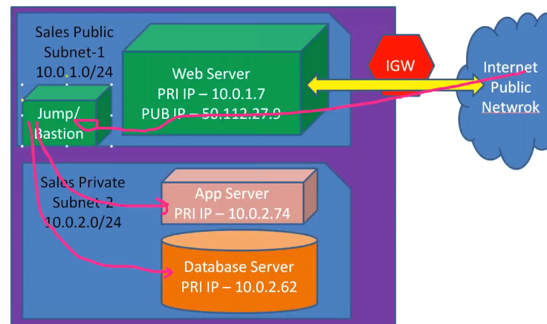

Create a file with the name of key or something and paste the key which we get to connect to the server and run the below command to connect the private server

Give chmod 600 permissions on key file

* **Ssh <IP of private server> -I key**

We should have permissions to access the key file

* In windows, just login to jump server and then we can connect to private server with remote desktop connection

**Deleting VPC:**

* We can not delete the VPC until and unless we terminate the instances under that VPC

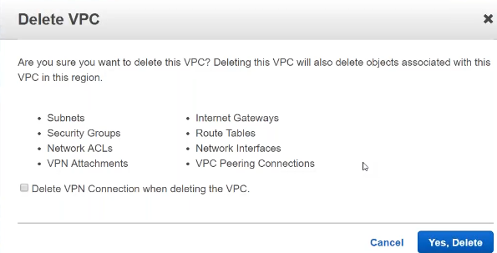

* It will delete all the above things when we delete the VPC

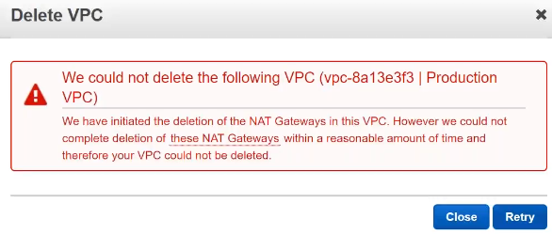

* Sometimes, we get above error while deleting. We need to wait for some time and retry

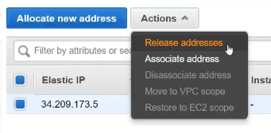

* Elastic IP won’t get delete after removing VPC. We need to release this manually. This is the last step we do while deleting the VPC

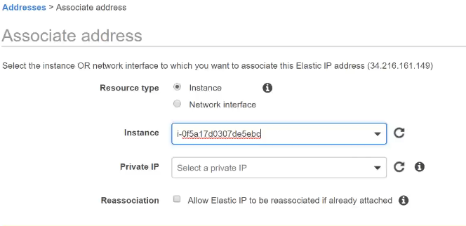

* After creating elastic IP, we need assign that to instance as above

**Direct connect:**

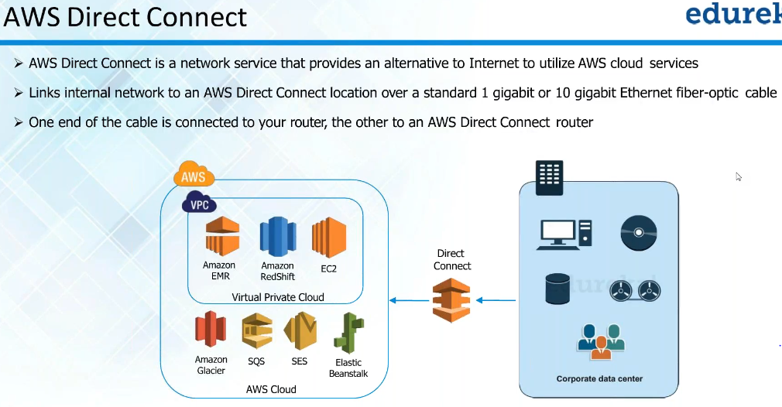

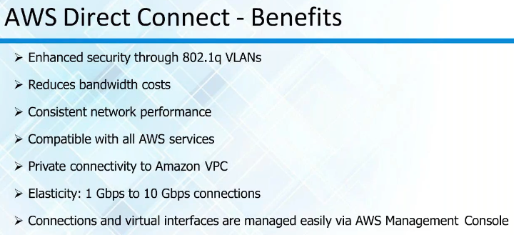

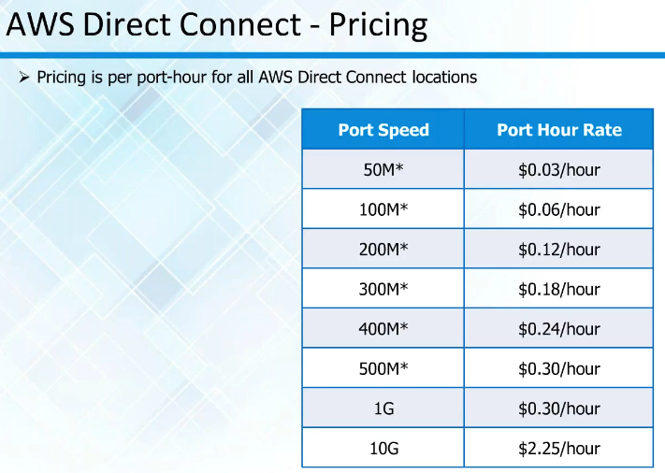

* Pricing depends on the region